WEEK-5
REACT-2
Cricket App (ES6 Features Integration)
The objective of this hands-on lab was to understand and apply modern ES6 JavaScript features within a React environment. This included using arrow functions, the map() method, array destructuring, the spread operator, and managing conditional rendering blocks.
The practical requirements were to:
- Create a new React application named cricketapp.
- Build a ListofPlayers component that declares an array of 11 players with names and scores, renders the complete list using the ES6 map feature, and uses an ES6 arrow function to filter and display players with scores below 70.
- Build an IndianPlayers component that uses ES6 array destructuring to separate and display odd-position and even-position team players, and uses the ES6 merge feature (spread operator) to combine separate T20 and Ranji Trophy player arrays into a single list.
- Integrate both components into the main home page (App.js), using a simple if-else condition controlled by a flag variable to display ListofPlayers when the flag is true, and IndianPlayers when the flag is false.

• Project Setup: Created the React project named cricketapp using the built-in IntelliJ project wizard, selecting the standard create-react-app CLI template configurations.
• Component Development: Created a dedicated Components directory within src and added two functional components:
- ListofPlayers.js: Declared the 11-player data structure. Used .map() to generate list items for all players. Implemented a .filter() method with an ES6 arrow function (player => player.score < 70) to create a secondary filtered view.
- IndianPlayers.js: Implemented ES6 array destructuring (const [player1, player2, player3, player4] = topPlayers) to extract individual index positions for the odd and even display. Used the spread operator ([...T20players, ...RanjiTrophyPlayers]) to merge separate player pools into a unified array.
• Conditional Page Routing: Updated the main App.js file by introducing a local boolean flag variable. Used a standard JSX ternary expression (flag ? <ListofPlayers/> : <IndianPlayers/>) to execute the required conditional rendering layout.
• Execution: Launched the development environment from the integrated IntelliJ terminal using the npm start command and verified the dynamic UI output changes on localhost:3000 by toggling the flag between true and false states.

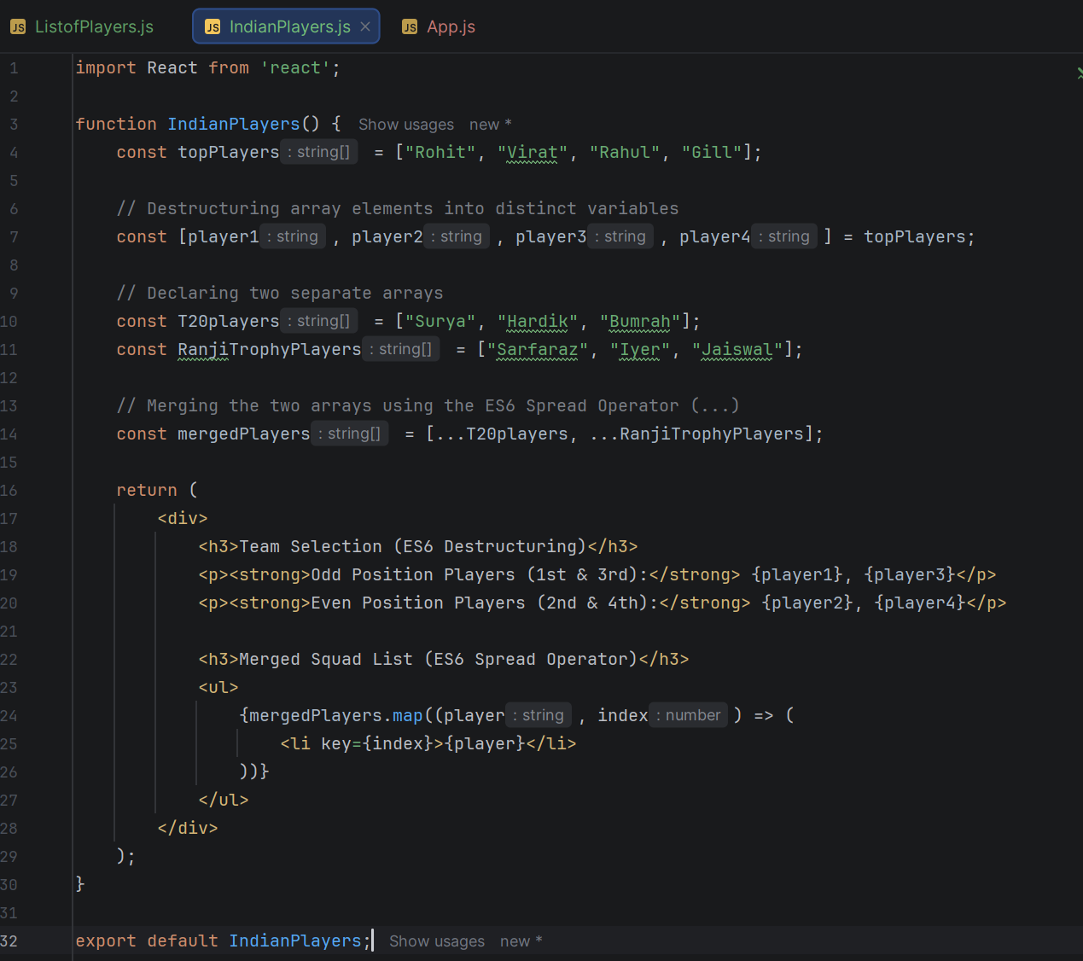
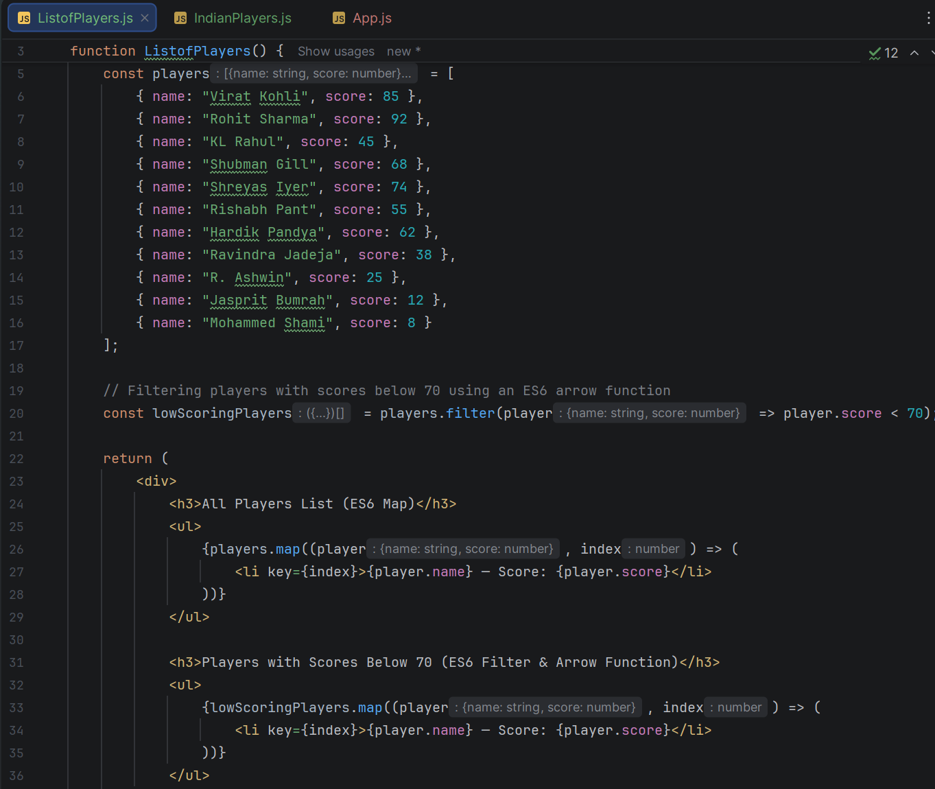
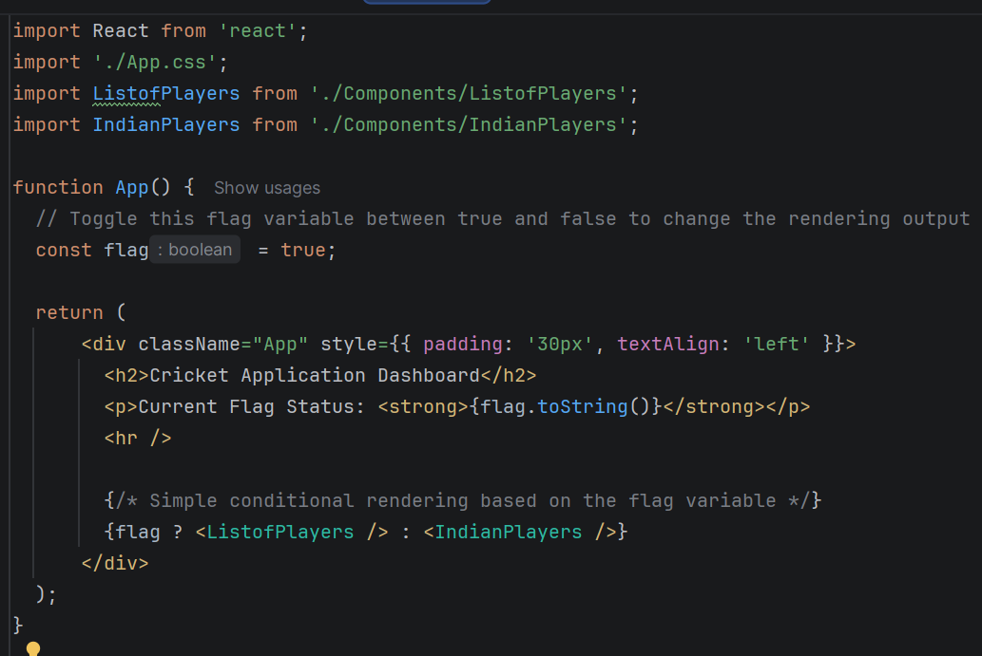
OUTPUT:
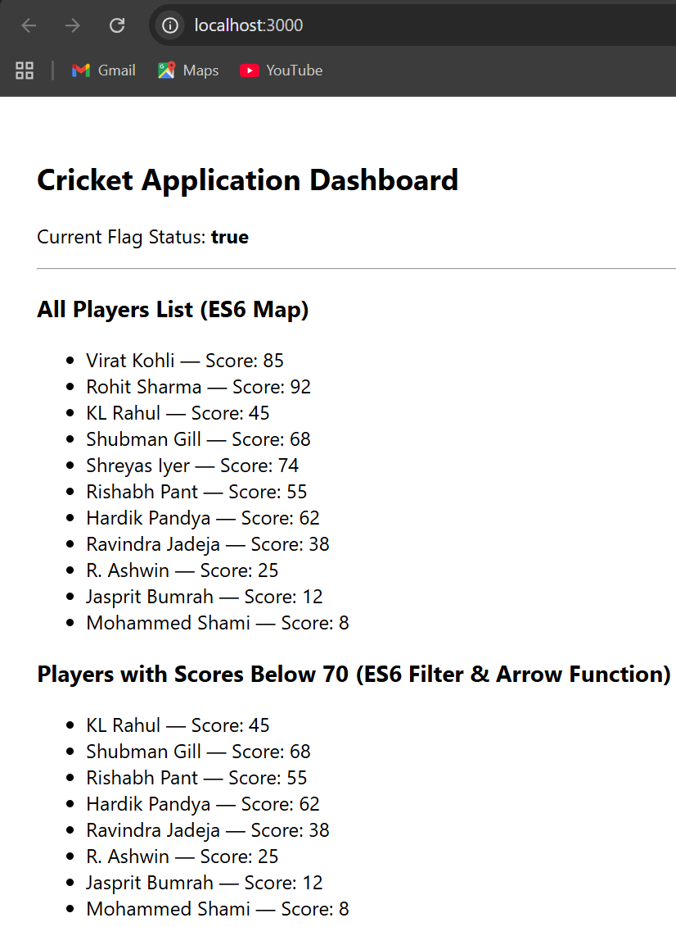

Office Space Rental App (JSX & Inline Styling)
The objective of this hands-on lab was to master React JSX fundamentals, including creating elements, managing JSX attributes, embedding JavaScript expressions, and implementing dynamic inline CSS styling.
The practical requirements were to:
- Create a new React application named officespacerentalapp.
- Store and render the main directory heading inside a JSX element variable.
- Pass image source URLs dynamically using standard JSX image attributes.
- Create a standalone JavaScript object representing an office property to display its details (Name, Rent, and Address).
- Create an array containing a list of multiple office objects and loop through them to generate a repeating layout structure.
- Apply conditional inline CSS to the rent display: format the text color in Red if the rent is below 60,000, and in Green if the rent is 60,000 or above.
• Project Initialization: Spawned a new React application directory named officespacerentalapp utilizing IntelliJ's New Project setup pane configured with the standard create-react-app CLI layout template.
• Component Architecture: Established a dedicated Components directory under the src root folder and built a custom OfficeSpace.js functional component file to isolate the app UI logic.
• Data Modeling & JSX Setup:
- Declared a constant variable holding an <h1> element block for the page header.
- Structured a featuredOffice block as a single entity, and an officeList array populated with multiple property mock objects containing distinct data for names, rent pricing integers, locations, and image URLs.
• Dynamic Map & Conditional Styling Insertion:
- Wrote the layout markup to output the individual featured card, loading the image asset via the standard JSX src={} attribute layout.
- Utilized an ES6 .map() function expression block to loop through the officeList array and uniformly duplicate the template design for all entries.
- Embedded a conditional JavaScript ternary operator directly into the inline style wrapper (style={{ color: office.rent < 60000 ? 'red' : 'green' }}) to toggle the visual color rendering engine dynamically based on pricing boundaries.
• Mounting & Deployment: Rewrote App.js to clean out standard boilerplate configurations, imported OfficeSpace, and nested the <OfficeSpace/> element structure directly into the target execution markup tree. Ran npm start within the terminal window to successfully verify the operational behavior at localhost:3000
import React from 'react';
function OfficeSpace() {
const pageHeading = <h1>Office Space Rental Directory</h1>;
const featuredOffice = {
name: "Alpha Premium Headquarters",
rent: 75000,
address: "123 Tech Park Avenue, Suite 400",
image: "https://images.unsplash.com/photo-1497366216548-37526070297c?auto=format&fit=crop&w=400&h=250&q=80"
};
const officeList = [
{
name: "Downtown Open Coworking",
rent: 45000,
address: "56 Corporate Boulevard",
image: "https://images.unsplash.com/photo-1539635278303-d4002c07eae3?auto=format&fit=crop&w=400&h=250&q=80"
},
{
name: "Skyline Executive Hub",
rent: 85000,
address: "88 Tower Road, Floor 22",
image: "https://images.unsplash.com/photo-1497215728101-856f4ea42174?auto=format&fit=crop&w=400&h=250&q=80"
},
{
name: "Suburban Innovation Lab",
rent: 58000,
address: "102 Technology Way",
image: "https://images.unsplash.com/photo-1524758631624-e2822e304c36?auto=format&fit=crop&w=400&h=250&q=80"
}
];

return (
<div style={{ padding: '20px', fontFamily: 'Arial, sans-serif' }}>
{/* Rendering the heading element */}
{pageHeading}

{/* Rendering a single object */}
<div style={{ border: '2px solid #333', padding: '15px', marginBottom: '30px', borderRadius: '8px', maxWidth: '400px' }}>
<h2>Featured Property</h2>
<img src={featuredOffice.image} alt={featuredOffice.name} style={{ width: '100%', borderRadius: '4px' }} />
<h3>{featuredOffice.name}</h3>
<p><strong>Address:</strong> {featuredOffice.address}</p>
<p>
<strong>Monthly Rent: </strong>
{/* Conditional inline CSS styling */}
<span style={{ color: featuredOffice.rent < 60000 ? 'red' : 'green', fontWeight: 'bold' }}>
₹{featuredOffice.rent}
</span>
</p>
</div>

{/* Rendering a list of objects using map() */}
<h2>All Available Spaces</h2>
<div style={{ display: 'flex', gap: '20px', flexWrap: 'wrap' }}>
{officeList.map((office, index) => (
<div key={index} style={{ border: '1px solid #ccc', padding: '15px', borderRadius: '8px', width: '280px' }}>
<img src={office.image} alt={office.name} style={{ width: '100%', height: '150px', objectFit: 'cover', borderRadius: '4px' }} />
<h3>{office.name}</h3>
<p><strong>Address:</strong> {office.address}</p>
<p>
<strong>Monthly Rent: </strong>
{/* Conditional inline CSS styling */}
<span style={{ color: office.rent < 60000 ? 'red' : 'green', fontWeight: 'bold' }}>
₹{office.rent}
</span>
</p>
</div>
))}
</div>
</div>
);
}
export default OfficeSpace;
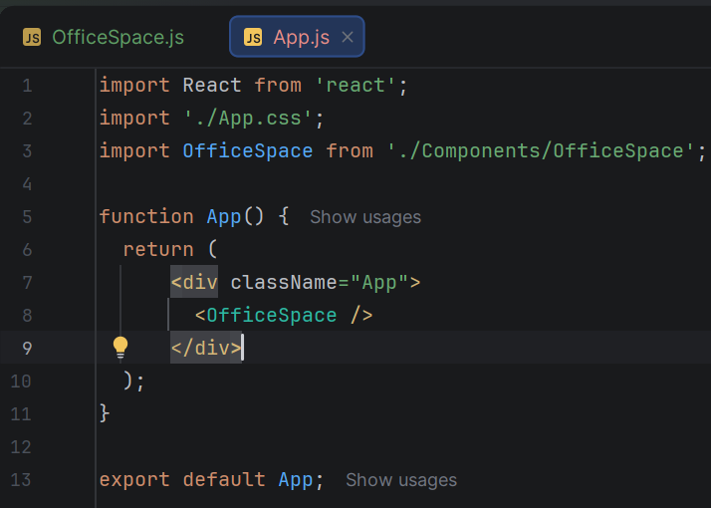
OUTPUT:
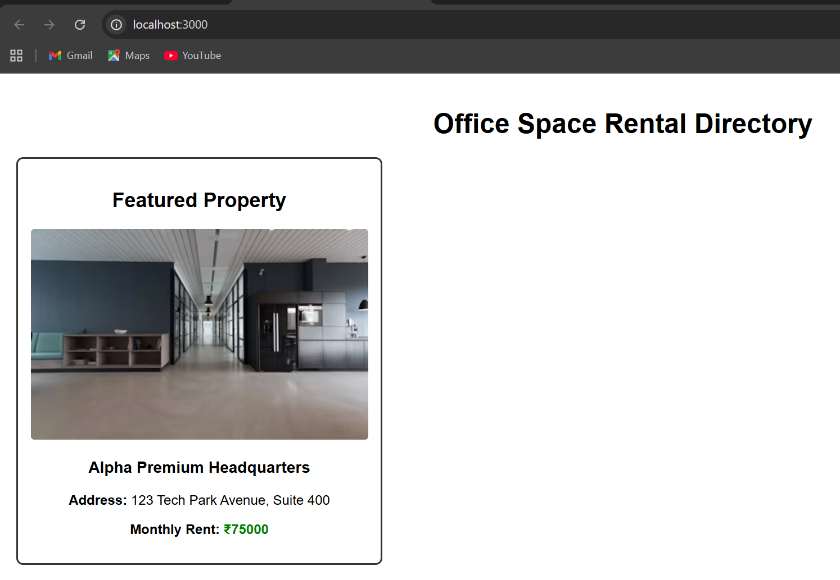

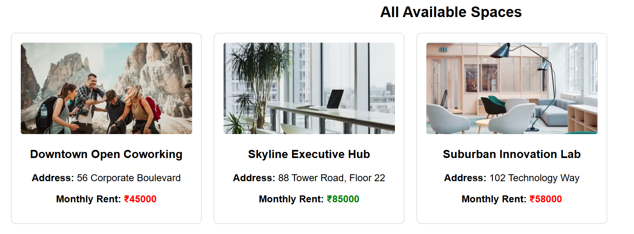

React Events and Forms Application
The objective of this hands-on lab was to understand React event systems, including event handlers, naming conventions, synthetic events, and managing execution context using the this keyword.
The practical requirements were to:
- Create a new React application named eventexamplesapp.
- Build an interactive counter with an "Increment" button that simultaneously updates the numerical state and invokes a secondary method to display a static "Hello" alert message.
- Build a "Decrement" button to decrease the counter value.
- Build a "Say Welcome" button that passes a custom text string ('welcome') as an argument to an alert function.
- Build a button that demonstrates a React Synthetic Event by intercepting the click and displaying an alert message reading "I was clicked".
- Build a CurrencyConvertor component that handles form submission through a handleSubmit event, dynamically converting Indian Rupees (INR) to Euros (EUR) and rendering the result.
- Project Initialization: Created a new React project directory named eventexamplesapp using the create-react-app architecture within the IntelliJ project wizard.
- Component Structure: Established a Components directory inside the src folder to cleanly isolate feature logic.
- Class Component Implementation (EventExamples.js): Implemented a class-based component to explicitly demonstrate the this keyword. Bound event handlers in the constructor to maintain correct execution context. Configured the increment logic to chain two internal functions, and wrapped the argument passing requirement in an inline arrow function definition.
- Form & Math Processing (CurrencyConvertor.js): Built a form structure that reads user input into the local state. Used the synthetic event's e.preventDefault() method inside handleSubmit to suppress the default browser page reload, isolating the conversion math safely within the UI tree.
- Assembly & Mounting: Cleaned out the boilerplate code in App.js, imported both functional files, and mounted them into a single coherent dashboard. Launched the development server using npm start in the terminal to verify all interactive elements on localhost:3000.

Project Source Code

File Name: src/Components/EventExamples.js
JavaScript
import React, { Component } from 'react';

class EventExamples extends Component {
constructor(props) {
super(props);
this.state = { counter: 0 };

// Explicit binding to demonstrate the 'this' keyword requirement
this.handleIncrement = this.handleIncrement.bind(this);
this.handleDecrement = this.handleDecrement.bind(this);
this.handleSyntheticEvent = this.handleSyntheticEvent.bind(this);
}

// Static message method invoked alongside counter incrementing
sayHello() {
alert("Hello! Welcome to the React Event Handling session.");
}

handleIncrement() {
// Method part A: Update state
this.setState(prevState => ({ counter: prevState.counter + 1 }));
// Method part B: Invoke secondary method
this.sayHello();
}

handleDecrement() {
this.setState(prevState => ({ counter: prevState.counter - 1 }));
}

// Method handling custom arguments
sayWelcome(message) {
alert(`Argument passed: ${message}`);
}

// Method handling React Synthetic Event properties
handleSyntheticEvent(e) {
alert("I was clicked");
console.log("Synthetic Event Type:", e.type);
}

render() {
return (
<div style={{ border: '1px solid #ccc', padding: '20px', marginBottom: '20px', borderRadius: '8px' }}>
<h3>1. Counter (Multiple Methods & 'this' Binding)</h3>
<p>Counter: <strong>{this.state.counter}</strong></p>
<button onClick={this.handleIncrement}>Increment</button>
<button onClick={this.handleDecrement} style={{ marginLeft: '10px' }}>Decrement</button>

<h3>2. Function with Arguments</h3>
<button onClick={() => this.sayWelcome('welcome')}>Say Welcome</button>

<h3>3. Synthetic Event</h3>
<button onClick={this.handleSyntheticEvent}>Trigger Event</button>
</div>
);
}
}

export default EventExamples;

File Name: src/Components/CurrencyConvertor.js
JavaScript
import React, { Component } from 'react';
class CurrencyConvertor extends Component {
constructor(props) {
super(props);
this.state = {
inr: '',
euro: 0
};
this.handleInputChange = this.handleInputChange.bind(this);
this.handleSubmit = this.handleSubmit.bind(this);
}

handleInputChange(e) {
this.setState({ inr: e.target.value });
}

handleSubmit(e) {
e.preventDefault();
const inputRupees = parseFloat(this.state.inr);
if (!isNaN(inputRupees) && inputRupees >= 0) {
const calculatedEuro = inputRupees / 90;
this.setState({ euro: calculatedEuro.toFixed(2) });
} else {
alert("Please enter a valid amount in INR.");
}
}

render() {
return (
<div style={{ border: '1px solid #ccc', padding: '20px', borderRadius: '8px' }}>
<h3>4. Currency Converter (INR to Euro)</h3>
<form onSubmit={this.handleSubmit}>
<div style={{ marginBottom: '10px' }}>
<label>Enter Rupees (INR): </label>
<input
type="number"
value={this.state.inr}
onChange={this.handleInputChange}
placeholder="e.g. 9000"
style={{ padding: '5px', marginLeft: '10px' }}
/>
</div>
<button type="submit" style={{ padding: '6px 12px', cursor: 'pointer' }}>Convert</button>
</form>
<p style={{ marginTop: '15px' }}>
Resulting Value: <strong>€ {this.state.euro}</strong>
</p>
</div>
);
}
}
export default CurrencyConvertor;
OUTPUT:
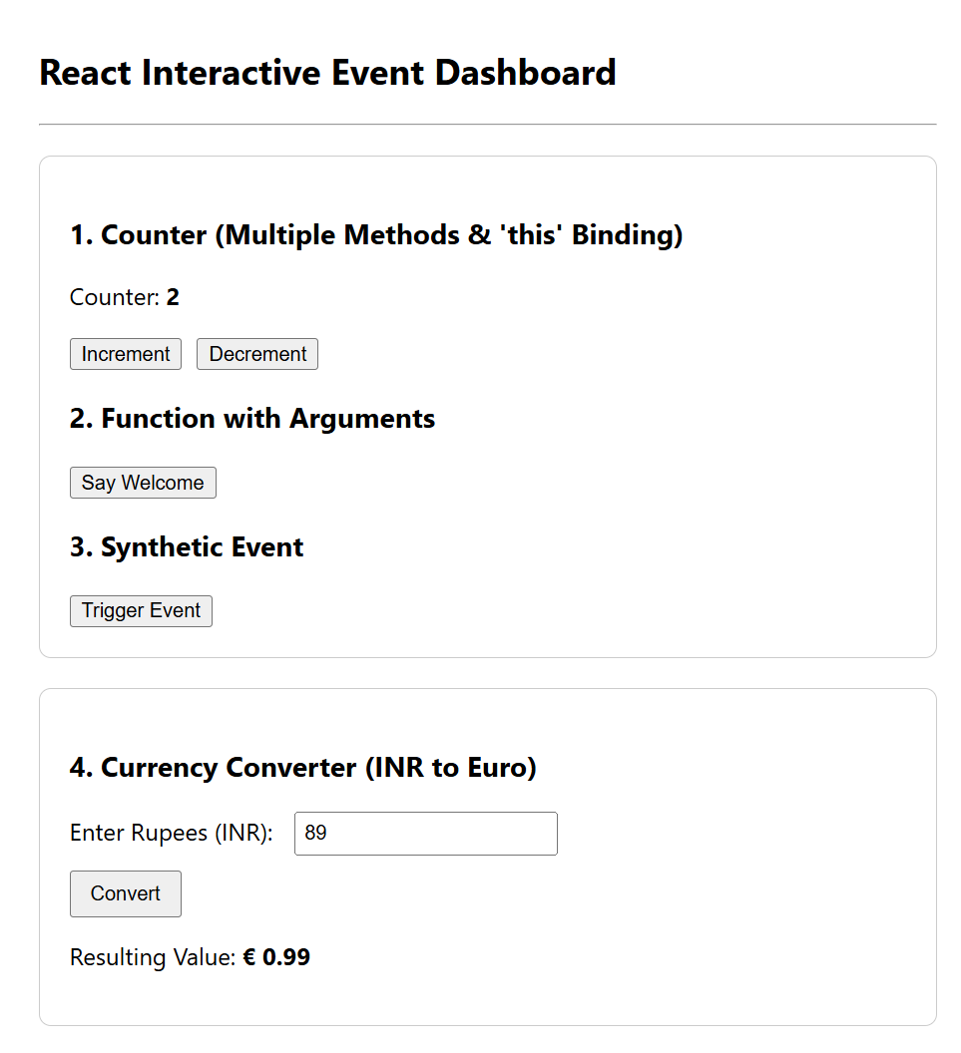

Ticket Booking Application
The primary objective of this hands-on lab was to master conditional rendering strategies in React. This involved using element variables to dynamically store blocks of JSX, implementing conditional statements, and learning how to prevent a component from rendering anything to the DOM.
The practical requirements for the system were to:
- Create a new React application named ticketbookingapp.
- Build a conditional views workflow where a guest user can only browse an informational list of available flights without the ability to book tickets.
- Allow a logged-in user to view an authorized booking dashboard containing functional "Book Ticket" buttons for each flight.
- Implement dynamic Login and Logout actions that change the app layout based on a boolean tracking state.
- Demonstrate core React rendering paradigms: element variables, short-circuit operators (&&), and blocking component layouts by returning null.
What Was Done (Implementation & Execution) To complete the lab requirements using IntelliJ IDEA, the following steps were executed:
- Project Initialization: Spawned a new React application workspace named ticketbookingapp using the create-react-app CLI template configurations.
- Component Architecture: Established a dedicated Components directory under the src root folder to modularize feature execution.
- Preventing Render Layout (ExclusiveOffers.js): Developed a functional component that accepts an authorization prop. Programmed an explicit check (if (!isLoggedIn) return null;) to verify that a component can completely block its own UI output when conditions are unmet.
- Element Variable Architecture (FlightBooking.js): Built a class component featuring local state properties. Declared empty script scope variables (authButton, viewGreeting, tableActionHeader) inside the render() block and loaded them with specific JSX code fragments inside an if-else block depending on the user's login status.
- Dynamic Grid Mapping: Configured an iterative list array using .map() to output custom rows for each flight. Embedded short-circuit execution steps directly in the table row structure to toggle the active booking column based on the login state.
- Integration Testing: Connected the complete page structure into App.js. Ran terminal deployment routines using npm start to confirm that headers, columns, action buttons, and discount blocks dynamically updated in the browser at localhost:3000.
Project Source Code
File Name: src/Components/ExclusiveOffers.js
JavaScript
import React from 'react';

function ExclusiveOffers({ isLoggedIn }) {
// Preventing the component from rendering entirely if user is a guest
if (!isLoggedIn) {
return null;
}

return (
<div style={{ backgroundColor: '#fff3cd', padding: '15px', marginTop: '20px', borderRadius: '5px', border: '1px solid #ffeeba', color: '#856404' }}>
<strong>🔥 Member Exclusive Deal:</strong> Use code <strong>FLY2026</strong> at checkout to save 10% on your selected flight ticket!
</div>
);
}

export default ExclusiveOffers;
File Name: src/Components/FlightBooking.js
JavaScript
import React, { Component } from 'react';
import ExclusiveOffers from './ExclusiveOffers';

class FlightBooking extends Component {
constructor(props) {
super(props);
this.state = {
isLoggedIn: false
};
this.handleLogin = this.handleLogin.bind(this);
this.handleLogout = this.handleLogout.bind(this);
}

handleLogin() {
this.setState({ isLoggedIn: true });
}

handleLogout() {
this.setState({ isLoggedIn: false });
}

render() {
const { isLoggedIn } = this.state;

// Declaring Element Variables to demonstrate conditional markup storage
let authButton;
let viewGreeting;
let tableActionHeader;

if (isLoggedIn) {
// Element variables populated for logged-in user page view
authButton = <button onClick={this.handleLogout} style={{ backgroundColor: '#dc3545', color: 'white', padding: '8px 16px', border: 'none', borderRadius: '4px', cursor: 'pointer' }}>Logout</button>;
viewGreeting = <h2 style={{ color: '#0056b3' }}>User Dashboard: Registered Ticket Booking Mode</h2>;
tableActionHeader = <th style={{ padding: '12px', borderBottom: '2px solid #ddd' }}>Purchase Option</th>;
} else {
// Element variables populated for standard anonymous guest browsing view
authButton = <button onClick={this.handleLogin} style={{ backgroundColor: '#28a745', color: 'white', padding: '8px 16px', border: 'none', borderRadius: '4px', cursor: 'pointer' }}>Login</button>;
viewGreeting = <h2 style={{ color: '#6c757d' }}>Guest Portal: Read-Only Flight Directory Mode</h2>;
tableActionHeader = null; // Prevents this specific column title node from rendering
}

// Static Flight Array
const flights = [
{ id: 201, flightNo: "AI-102", route: "New Delhi (DEL) to Mumbai (BOM)", price: "₹6,400" },
{ id: 202, flightNo: "6E-432", route: "Hyderabad (HYD) to Bengaluru (BLR)", price: "₹3,900" },
{ id: 203, flightNo: "UK-811", route: "Kolkata (CCU) to Chennai (MAA)", price: "₹7,200" }
];

return (
<div style={{ padding: '30px', fontFamily: 'Arial, sans-serif', maxWidth: '800px', margin: '0 auto' }}>
<div style={{ display: 'flex', justifyContent: 'space-between', alignItems: 'center', borderBottom: '3px solid #343a40', paddingBottom: '15px' }}>
<h1 style={{ margin: 0 }}>SkyRoute Airways</h1>
{/* Rendering the button element variable */}
{authButton}
</div>

<div style={{ marginTop: '20px' }}>
{/* Rendering the greeting message element variable */}
{viewGreeting}
</div>

<table style={{ width: '100%', marginTop: '20px', borderCollapse: 'collapse', textAlign: 'left' }}>
<thead>
<tr style={{ backgroundColor: '#f8f9fa' }}>
<th style={{ padding: '12px', borderBottom: '2px solid #ddd' }}>Flight Number</th>
<th style={{ padding: '12px', borderBottom: '2px solid #ddd' }}>Route Details</th>
<th style={{ padding: '12px', borderBottom: '2px solid #ddd' }}>Standard Price</th>
{/* Rendering table header column via element variable */}
{tableActionHeader}
</tr>
</thead>
<tbody>
{flights.map(flight => (
<tr key={flight.id} style={{ borderBottom: '1px solid #eee' }}>
<td style={{ padding: '12px' }}>{flight.flightNo}</td>
<td style={{ padding: '12px' }}>{flight.route}</td>
<td style={{ padding: '12px' }}>{flight.price}</td>

{/* Inline Conditional Short-Circuit Execution for Booking Buttons */}
{isLoggedIn && (
<td style={{ padding: '12px' }}>
<button
onClick={() => alert(`Success! Seat reserved on flight ${flight.flightNo}.`)}
style={{ backgroundColor: '#007bff', color: 'white', border: 'none', padding: '6px 12px', borderRadius: '4px', cursor: 'pointer' }}
>
Book Ticket
</button>
</td>
)}
</tr>
))}
</tbody>
</table>

{/* Passing state property down to show dynamic component rejection pattern */}
<ExclusiveOffers isLoggedIn={isLoggedIn} />
</div>
);
}
}

export default FlightBooking;
File Name: src/App.js
JavaScript
import React from 'react';
import './App.css';
import FlightBooking from './Components/FlightBooking';

function App() {
return (
<div className="App">
<FlightBooking />
</div>
);
}

export default App;
OUTPUT:
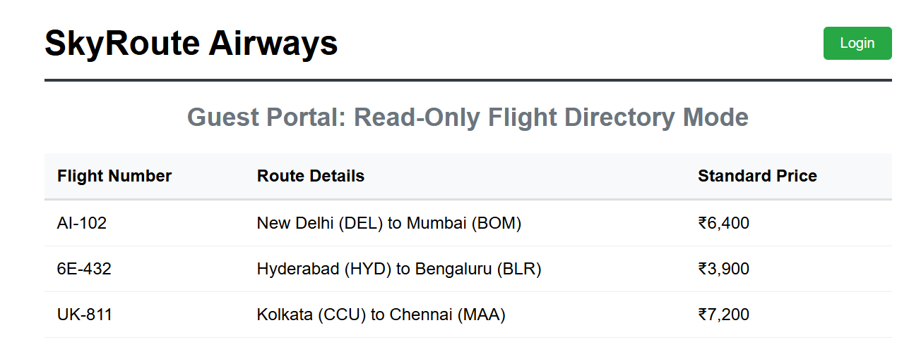

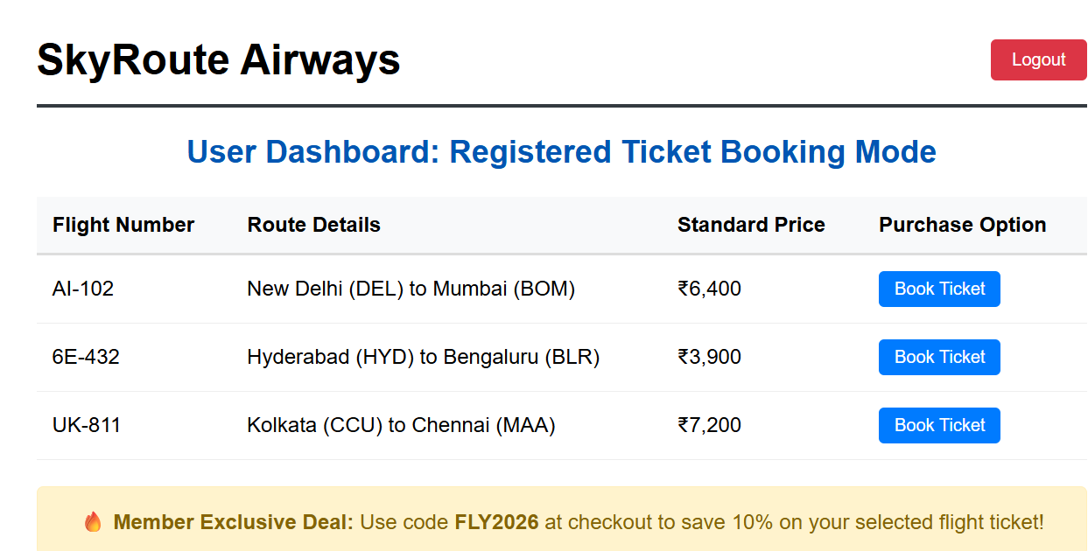

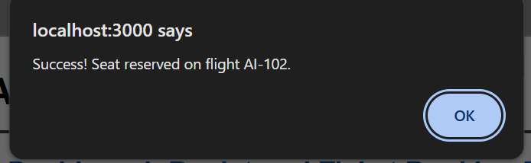

Blogger Application
The objective of this hands-on lab was to understand lists, keys, and advanced conditional rendering methods in React.
The requirements for this project were to:
- Create a React application named bloggerapp.
- Build three distinct components: Book Details, Blog Details, and Course Details.
- Implement as many conditional rendering techniques as possible (such as if-else logic, element variables, ternary operators, short-circuit evaluation, and returning null).
- Demonstrate rendering multiple components inside a main view.
- Use the JavaScript map() function to render lists, explain the purpose of unique key props, and show how to safely extract child components with keys.
What Was Done (Implementation & Execution) To complete the lab requirements using IntelliJ IDEA 2026.1.3, the following tasks were carried out:
- Project Workspace Setup: Generated the base app repository labeled bloggerapp using the create-react-app framework template configurations.
- Element Variable Switchboard (BloggerDashboard.js): Built a main dashboard with tab buttons to manage multiple child views. It uses an element variable (displayMarkupContent) populated by an if-else statement to switch between the three primary feature components based on state.
- Component Extraction & Keys (BookDetails.js): Implemented an array of book data looped over by a React Map (map()) statement. Extracted the list design into a separate child component (BookItem) and assigned the unique key prop to the custom element in the parent loop to keep the DOM stable.
- Short-Circuit Evaluation (BlogDetails.js): Built a list layout displaying blog posts. Used an inline short-circuit operator (&&) to look at each item's property and dynamically attach a "Featured Star" badge only if the value is true.
- Ternary Rendering & Component Hiding (CourseDetails.js): Created a conditional switch that alternates layout shapes (List view vs. Grid view) instantly using a ternary operator (? :). Also included a system banner component (MaintenanceBanner) that completely prevents rendering by returning null when a toggle condition is met.
- System Assembly: Connected the main dashboard inside App.js and confirmed smooth performance across all conditional paths in the browser.
Project Source Code
File Name: src/Components/BookDetails.js
JavaScript
import React from 'react';
function BookItem({ title, author, year }) {
return (
<div style={{ padding: '12px', margin: '10px 0', borderLeft: '4px solid #007bff', backgroundColor: '#f8f9fa' }}>
<h4 style={{ margin: '0 0 5px 0' }}>{title}</h4>
<p style={{ margin: 0, fontSize: '0.9rem', color: '#555' }}>By {author} | Published: {year}</p>
</div>
);
}

function BookDetails() {
const books = [
{ id: 'b1', title: "Eloquent JavaScript", author: "Marijn Haverbeke", year: 2018 },
{ id: 'b2', title: "Designing Data-Intensive Applications", author: "Martin Kleppmann", year: 2017 },
{ id: 'b3', title: "You Don't Know JS Yet", author: "Kyle Simpson", year: 2020 }
];

return (
<div>
<h3>📚 Book Resource Library</h3>
<p style={{ color: '#666' }}>Rendering extracted child items using map() loops with unique identities.</p>

{/* React Map execution: Transforming array data into JSX collection elements */}
{books.map((book) => (
<BookItem
key={book.id}
title={book.title}
author={book.author}
year={book.year}
/>
))}
</div>
);
}

export default BookDetails;
File Name: src/Components/BlogDetails.js
JavaScript
import React from 'react';

function BlogDetails() {
const posts = [
{ id: 'p1', title: "Mastering React State Hooks", category: "Development", isFeatured: true },
{ id: 'p2', title: "A Guide to Tailwind CSS Layouts", category: "Design", isFeatured: false },
{ id: 'p3', title: "Understanding AI Core Orchestrators", category: "AI/ML", isFeatured: true }
];

return (
<div>
<h3>📰 Editorial Blog Catalog</h3>

{posts.map((post) => (
<div key={post.id} style={{ padding: '15px', borderBottom: '1px solid #ddd' }}>
<h4 style={{ margin: '0 0 5px 0', display: 'flex', alignItems: 'center', gap: '10px' }}>
{post.title}

{/* Short-Circuit Rendering: Tag renders only if isFeatured evaluates to true */}
{post.isFeatured && (
<span style={{ backgroundColor: '#ffc107', color: '#212529', fontSize: '0.75rem', padding: '2px 6px', borderRadius: '4px' }}>
Featured Star
</span>
)}
</h4>
<span style={{ fontSize: '0.8rem', color: '#6c757d', textTransform: 'uppercase' }}>{post.category}</span>
</div>
))}
</div>
);
}

export default BlogDetails;
File Name: src/Components/CourseDetails.js
JavaScript
import React, { useState } from 'react';
function MaintenanceBanner({ active }) {
if (active) {
return null;
}
return (
<div style={{ backgroundColor: '#d4edda', color: '#155724', padding: '10px', borderRadius: '4px', margin: '10px 0' }}>
✓ All systems online. Syncing active registrations.
</div>
);
}

function CourseDetails() {
const [hideBanner, setHideBanner] = useState(false);
const [viewFormat, setViewFormat] = useState('list'); // 'list' or 'grid'
const courses = [
{ id: 'c1', title: "Full-Stack Web Architectures", duration: "12 Weeks" },
{ id: 'c2', title: "Deep Learning Foundations", duration: "8 Weeks" },
{ id: 'c3', title: "Advanced Prompt Engineering Matrix", duration: "4 Weeks" }
];
return (
<div>
<h3>🎓 Learning Course Curriculum</h3>
<MaintenanceBanner active={hideBanner} />

<div style={{ marginBottom: '15px', display: 'flex', gap: '10px' }}>
<button onClick={() => setHideBanner(!hideBanner)} style={{ fontSize: '0.8rem', padding: '5px 10px' }}>
Toggle Status Notification Banner
</button>
<button onClick={() => setViewFormat(viewFormat === 'list' ? 'grid' : 'list')} style={{ fontSize: '0.8rem', padding: '5px 10px' }}>
Switch View Mode
</button>
</div>
{viewFormat === 'list' ? (
<div style={{ display: 'flex', flexDirection: 'column', gap: '8px' }}>
{courses.map(course => (
<div key={course.id} style={{ border: '1px solid #ccc', padding: '10px', borderRadius: '4px' }}>
<strong>{course.title}</strong> — {course.duration}
</div>
))}
</div>
) : (
<div style={{ display: 'grid', gridTemplateColumns: '1fr 1fr', gap: '12px' }}>
{courses.map(course => (
<div key={course.id} style={{ border: '2px dashed #007bff', padding: '15px', borderRadius: '6px' }}>
<h4>{course.title}</h4>
<p style={{ margin: 0, color: '#007bff' }}>{course.duration}</p>
</div>
))}
</div>
)}
</div>
);
}

export default CourseDetails;
File Name: src/Components/BloggerDashboard.js
JavaScript
import React, { useState } from 'react';
import BookDetails from './BookDetails';
import BlogDetails from './BlogDetails';
import CourseDetails from './CourseDetails';
function BloggerDashboard() {
const [activeTab, setActiveTab] = useState('books');
let displayMarkupContent;
if (activeTab === 'books') {
displayMarkupContent = <BookDetails />;
} else if (activeTab === 'blogs') {
displayMarkupContent = <BlogDetails />;
} else if (activeTab === 'courses') {
displayMarkupContent = <CourseDetails />;
} else {
displayMarkupContent = <p>No items found.</p>;
}
const getTabStyle = (tabName) => ({
padding: '10px 20px',
cursor: 'pointer',
border: 'none',
backgroundColor: activeTab === tabName ? '#343a40' : '#e2e6ea',
color: activeTab === tabName ? 'white' : 'black',
borderRadius: '4px 4px 0 0',
fontWeight: 'bold'
});
return (
<div style={{ fontFamily: 'Arial, sans-serif', maxWidth: '800px', margin: '30px auto', padding: '0 20px' }}>
<h1 style={{ textAlign: 'center', color: '#2c3e50', borderBottom: '2px solid #eee', paddingBottom: '10px' }}>
Universal Blogger Platform Matrix
</h1>
<div style={{ display: 'flex', gap: '5px', borderBottom: '2px solid #343a40', marginTop: '20px' }}>
<button onClick={() => setActiveTab('books')} style={getTabStyle('books')}>Books Hub</button>
<button onClick={() => setActiveTab('blogs')} style={getTabStyle('blogs')}>Blog Portal</button>
<button onClick={() => setActiveTab('courses')} style={getTabStyle('courses')}>Course Base</button>
</div>
<div style={{ padding: '20px', border: '1px solid #ddd', borderTop: 'none', borderRadius: '0 0 4px 4px', minHeight: '300px' }}>
{displayMarkupContent}
</div>
</div>
);
}
export default BloggerDashboard;
File Name: src/App.js
import React from 'react';
import './App.css';
import BloggerDashboard from './Components/BloggerDashboard';
function App() {
return (
<div className="App">
<BloggerDashboard />
</div>
);
}
export default App;

OUTPUT:

